**HOSPITAL INFORMATION MANAGEMENT SYSTEM (HIMS)**

**Software Improvement Document**

**Identify Actor/ Administrator for the software’s Setup Forms (Central Repository).**

**Central Repository:**

**1) Classification Form:**

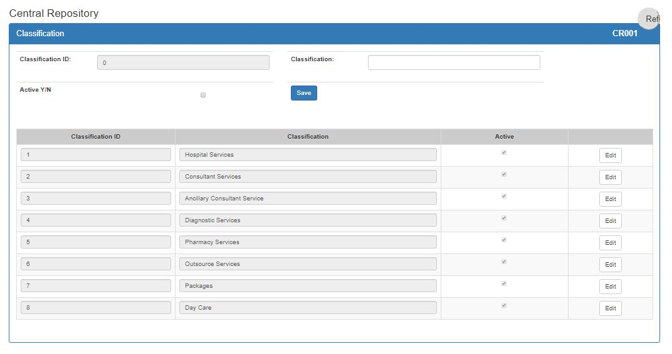

**2) Sub-Classification Form:**

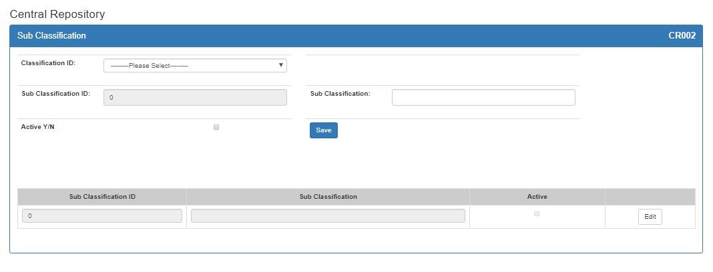

**3) Category Form:**

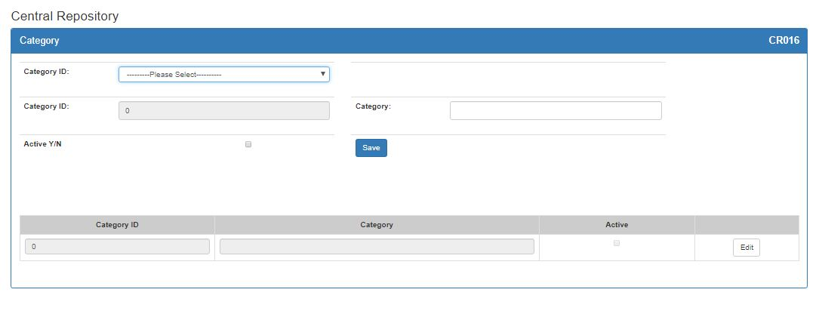

* Dropdown label name should be sub-classification.

**4) Sub-Category Form:**

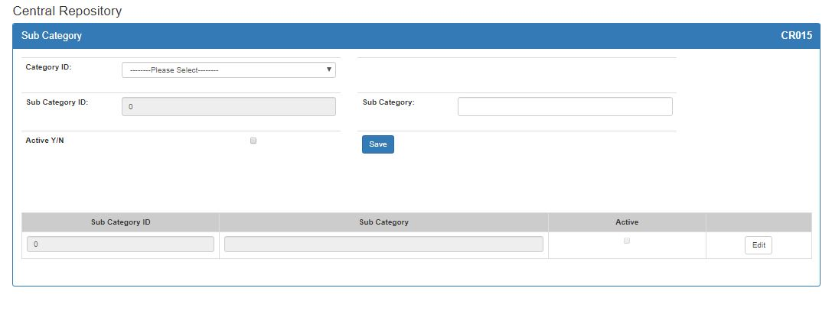

**5) Service Form:**

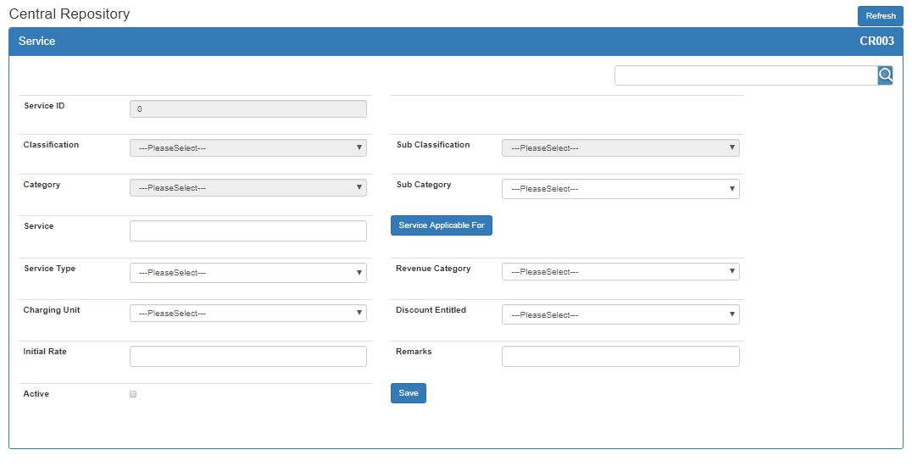

* OT Procedures are listed by Types not with their specific names. List of OT Procedures should be decided and added into the service list.
* Classification, Sub classification and Category list aren’t showing for selection and filtration of Sub-Category and when user View any service.
* **Current Procedural Terminology** (CPT)/ **International Classification of Diseases** (ICD) code Mapping of OT Procedures.

**6) Consultant:**

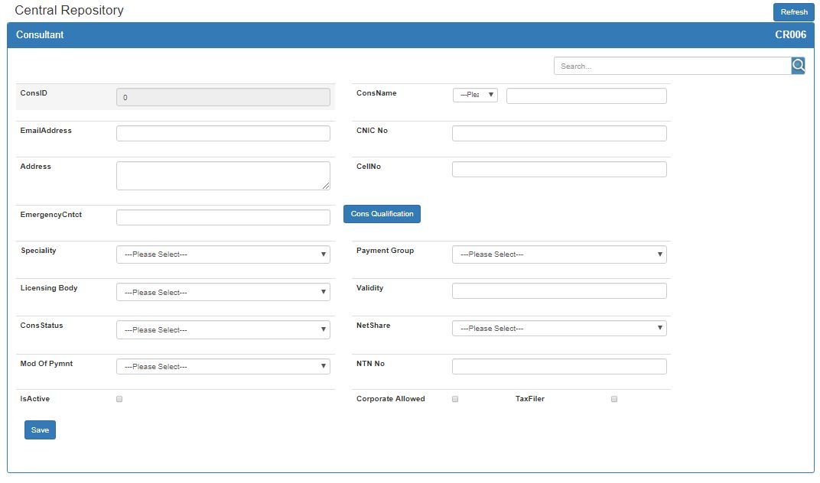

* Consultant Certification can be multiple and currently there’s one certification/License selection option on Form. So, there should be multiple certificates and certificates expiry date selection option.
* Intimation/Reminder for Consultants Certifies expiry (by Human Resource Department).

**7) Rate List Revision:**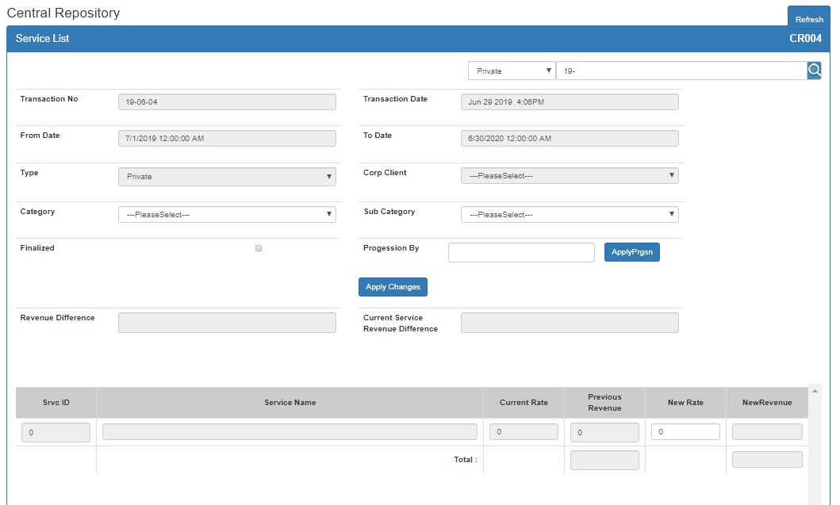

* Date formats should be same in all application (UK Format).
* Rate List expiry should be created using only From date instead of From and To Date to avoid expiry and redundancy on data.

**9) Corporate Client:**

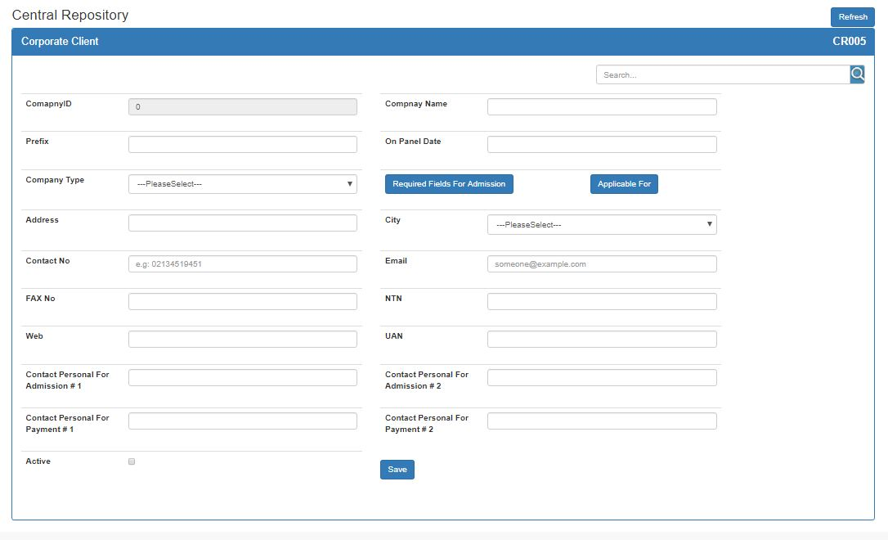

* Charity Organization or NGOs option should be added to Company Type.
* Diagnostic and Pharmacy can be added to applicable list of corporate clients.
* Credit days for each company.

**9) Department:**

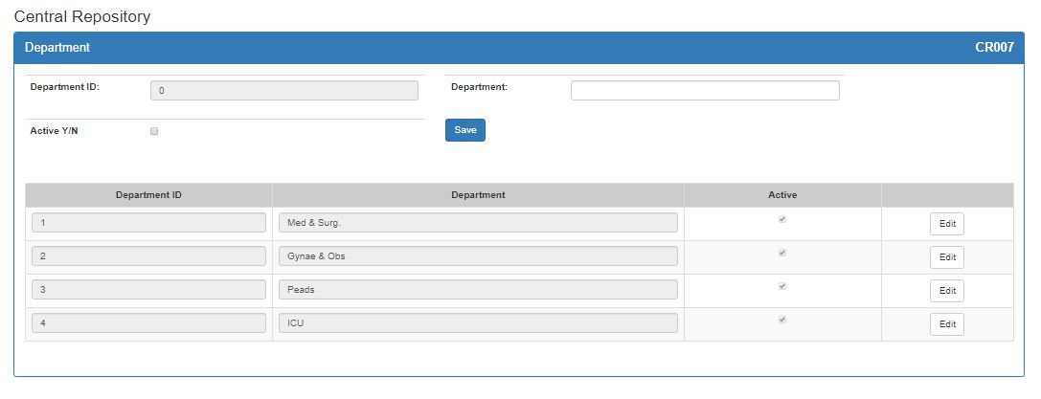

* Another head ‘Services’ above Department will be added.
* All Department of hospital will be added.
* Department Nature should be added if department is ward or not. If Department’s Nature is ward then bed can be added in that department or ward otherwise not.
* Medicine and Surgery Department should be Separate.

**10) Ward/Unit:**

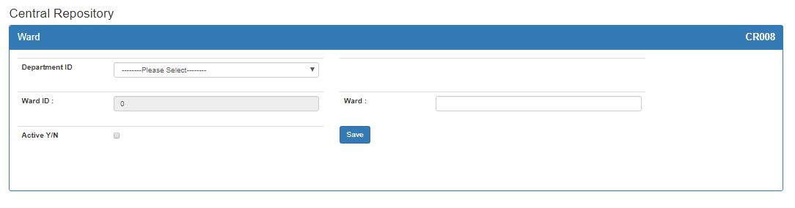

**11) Bed Category:**

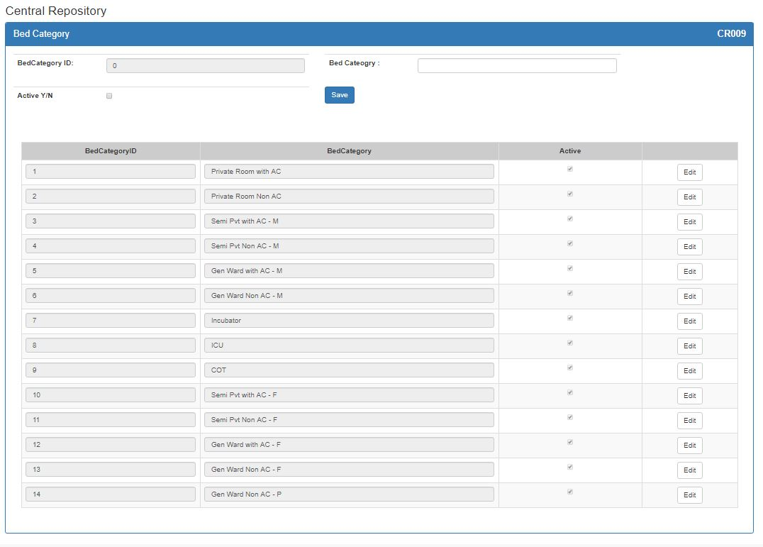

* Will be discussed later in detail.
* Bed Nature should be defined. (I.e. emergency bed, radiology bed, Cart, Male bed or Female bed). So that when allocating a bed to patient system should check that if that bed can be allocated to that particular patient or not.

**12) Bed:**

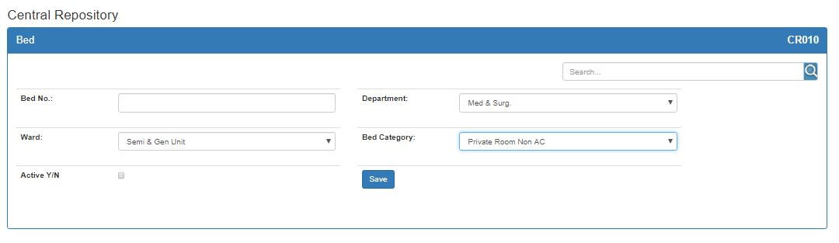

* If Department’s Nature is ward then bed can be added in that department or ward otherwise not.
* Bed’s location should be added.

**13) Advance Required Protocol:**

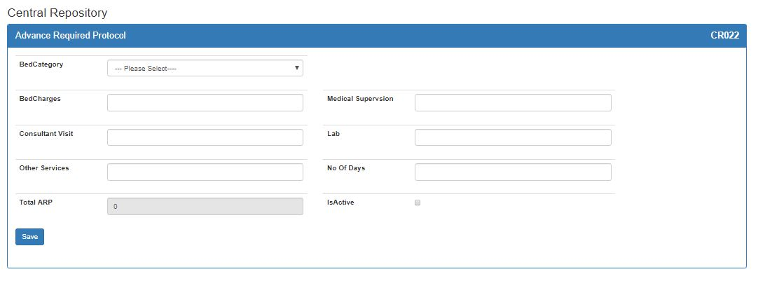

* Advance calculation fields i.e. Bed Charges, Consultant Visit, Medical Supervision, Lab and other services can be more utilized and used for comparison reports.
* Pharmacy services charges should be added.

**Admission and Discharge:**

**14) Patient Admission Form:**

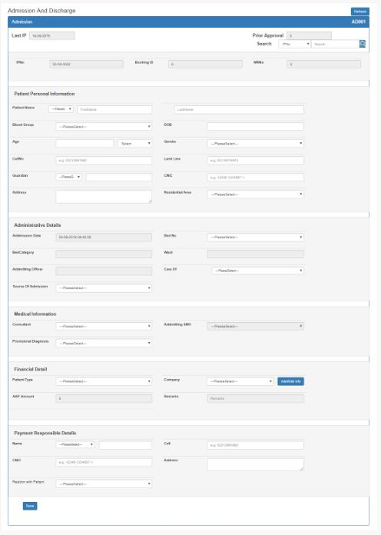

* Mandatory fields should de represented with star (*).
* Date of birth should be calculated according to entered Age.
* City should be added for selection of Patient address.
* Province/Cities/Areas List will be added to Database.
* Bed Category and Ward is not showing on selection of bed.
* There should be option of marking that if Payment responsible person is Next of Kin if not then Next of Kin information portion should be appear in form. Person name, contact, address, NIC and relation with patient will be required fields.
* For Corp clients, there should be option to select multiple companies, patient’s bill can be charged on multiple companies because companies/Organization have plans and payment limits. If one company’s payment limits end remaining bill could be charged on other selected company and if patient belongs to only one company there should be option to charge remaining bill as private patient. (This can also be done on payment form while charging a bill)
* Fixation of Patient information Portion on scrolling.
* When allocating a bed to patient there should be an option to mark that bed is isolated (i.e. if patient have any spreading disease and infection previous and bed next to that bed can’t be allocated to another patient till than isolated bed declared infection free.)

**15) Patient Bed Shift Form:**

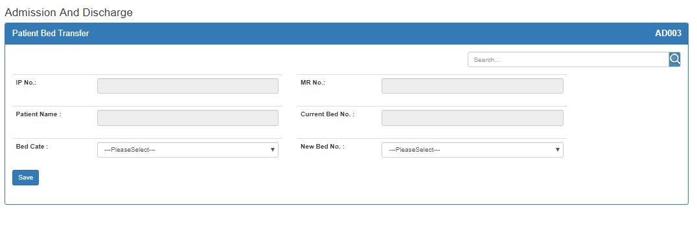

* When patient shifts to another ward, that ward staff should concern.
* Financial system control is missing.

**15) Booking Form:**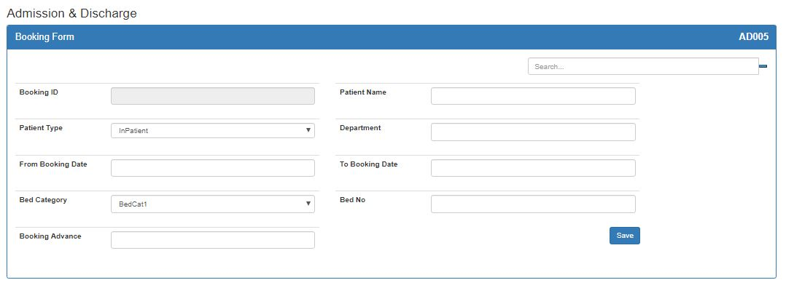

* Patient should be already registered with MR No.
* For OT and Ward booking selection of OT Category, Bed Category and Consultant will be mandatory. Bed No. will be optional.
* Already occupied beds with dates should display.
* Booked patient list should be display.
* There should be cancel booking option.
* Extra facilities for Long distance patients.

**16) Patient Advance and Payment Form:**

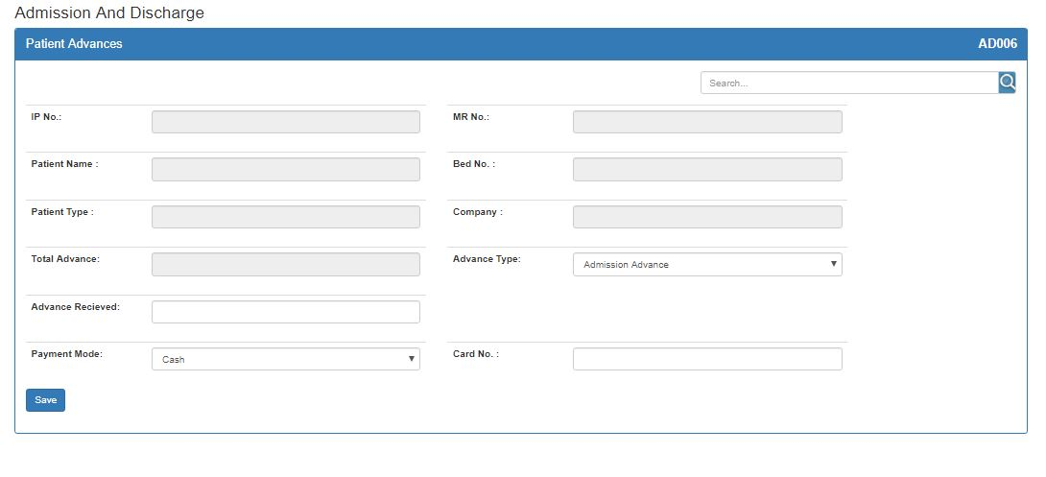

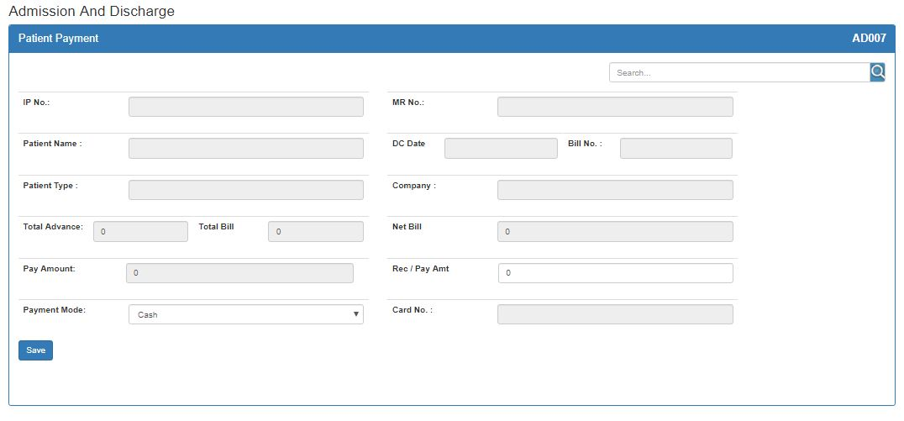

* Patient advance and Bill payment form should be merged in one form.
* Advance type field is extra and unnecessary.
* All other payment forms of other software should be merged with this form. There should be only one form for all types of payments.
* Patient search list should be in descending order.
* Admission date is missing from Patient advance form.
* Recursive formats in search and multiple search functionality.
* Search results should be view on Pop Up.
* All forms are flickering.
* There should be multiple payment options i.e. Card, QR Code, Easy Paisa and online payments.
* New fields for Card no., Bank name, card expiry, validation no. should be added.

**17) Patient Consultant Transfer Form:**

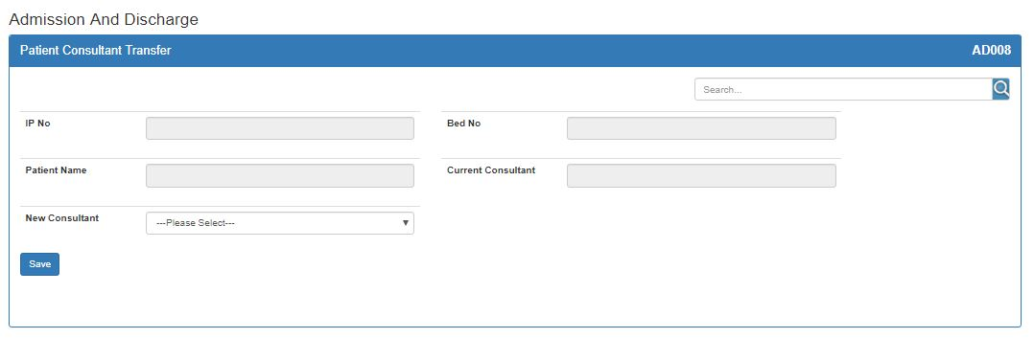

* There is no option for selecting Secondary consultant. There should be option for multiple Secondary consultant. (Joint Consultation)
* Primary consultant of patient is one and secondary consultant can be more than one.

**18) Intimation Form:**

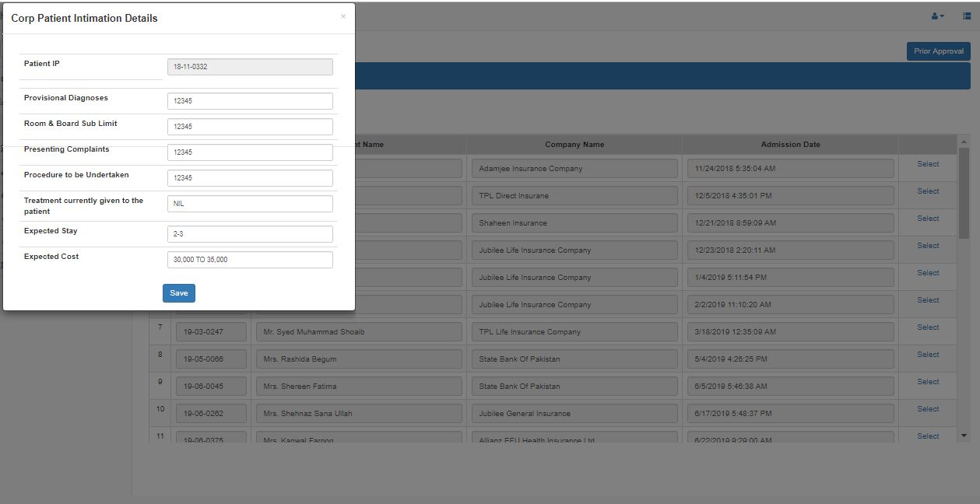

* Diagnosis shouldn’t enter in text it should be dropdown to prevent chances of mistake and wrong data entry.
* There should be some time of validation on each field to avoid mistakes.
* Intimation email should send automatically.

**Billing:**

**19) Daily Bill:**

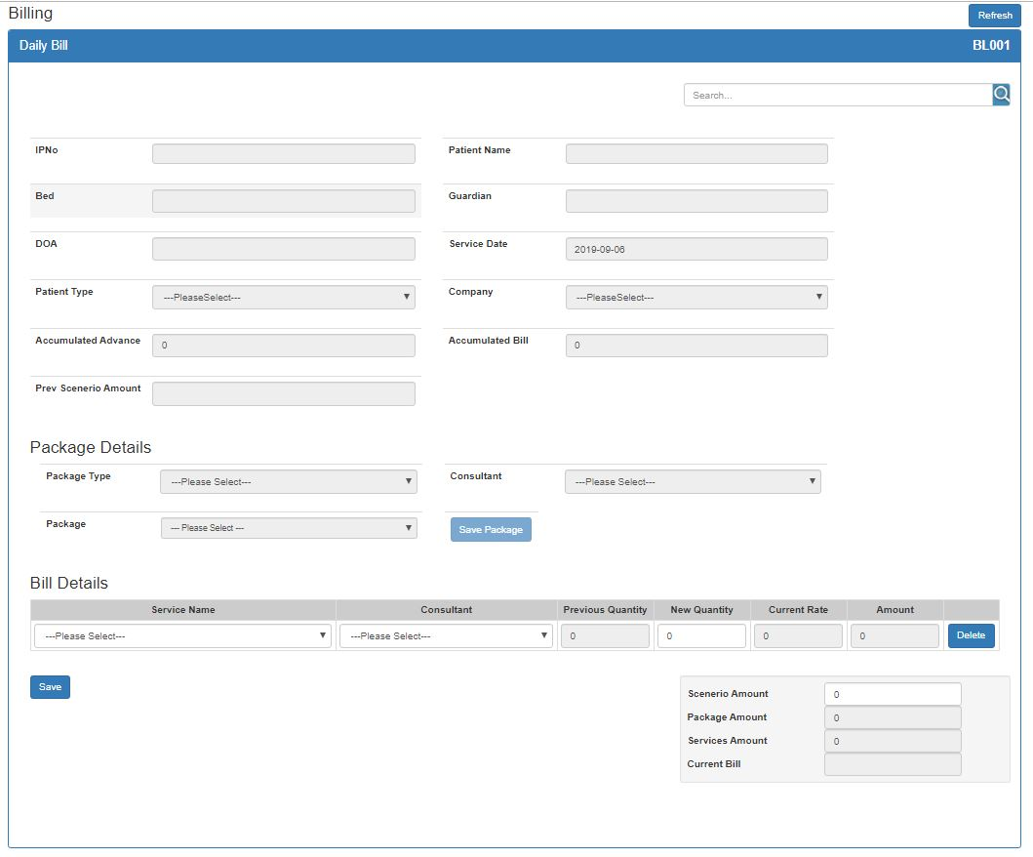

* Validations to avoid mistakes and wrong data entry.
* Form flow is complex it should be user friendly.
* Charges that can be calculated automatically should be calculated automatically for each admitted patient through any process (i.e. Bed Charges, Medical Supervision, RMO charges).
* Admission Fee should be calculated automatically when patient admitted.
* Radiology charges entry should be done by Radiology counter at the time of service.
* Pharmacy charges should be charged automatically in bill from pharmacy.
* Minimizing manual entry from billing.
* Patient should be able to view his daily bill.

**New Additions**

1. Nursing Staff addition Form.
2. Every Patient who come to Pharmacy should register (Short Registration) in our system and allocate a MR No. For registration First name, Last name, age, gender and contact no. will be required.
3. Auto process of daily charging bed services for all admitted patients to prevent manual bed charging.
4. Calculate Date of birth for current patient’s data.
5. There should be a bill cancelation form and rights should be provided to HOD.
6. Credit days for each company.
7. We need to create a structure for Lab from which they can push Patient data i.e. Lab results and we can pull that data in our database.
8. RFID Cards implementation for IPD and OPD Patients. When RFID card can’t be given send RFID No. to patients via SMS.
9. Patient Registration form for all Patients.

**Patient Receiving Form:**

* There should be a Patient Receiving form for Nurse.
* When patient is admitted in any ward nurse will fill up that form.
* Medical Record of patient should be hand over to nurse.
* Patients Vitals, History and Patient’s valuable should be marked by nurse through that form.

**Appointment System:**

* There should be an appointment entry form.
* Option to select specialty wise Physician.
* Physician timings and slots limit should display.
* Option to view monthly schedule. Booked and available slots and slots limit.
* There should be also a Holidays marking form.
* Marked holidays should display in physicians schedule with any permanent color.
* Booked slots list should display with patients information and appointment timings.
* The already booked slots will not be available for anyone else for the specified time.
* Option to search patient if already registered and if not, new registration should be done.
* Option to save and cancel Appointment.

**Web-based Appointment System:**

* Web-based Appointment request.
* Request list should display to FDO.
* Request Confirmation from counter by FDO on call.
* On delay or cancelation of appointment inform to Patient on call.
* Appointment form with options to View free or booked slots, list of patients and cancel appointments.

**Our Process and TimeLine**

|  |  |  |  |
| --- | --- | --- | --- |
|  | **Processes** | **TimeLine** |  |
| 1 | SRS |  |  |
| 2 | Use Cases |  |  |
| 3 | Development |  |  |
| 4 | QC |  |  |

**New Tasks**

|  |  |  |
| --- | --- | --- |
| **Task** | **Sub Tasks** |  |
| Patient Registration form |  |  |
| Appointment form |  |  |